**INTRODUCTION TO STATISTICAL CONCEPTS**

**ASSIGNMENT 2A**

**Chapter 5: Probability**

1. (a) What is the probability of rolling a pair of dice and obtaining a total score of 9 or more? (b) What is the probability of rolling a pair of dice and obtaining a total score of 7? ([relevant section](http://onlinestatbook.com/2/probability/basic.html))
   * The probability of rolling a pair of dice and getting 9 or more is 10/36 or 0.2777 (yellow)
   * The probability of rolling pair of dice and getting a score of 7 is 6/36 or 0.166 (orange)
   * 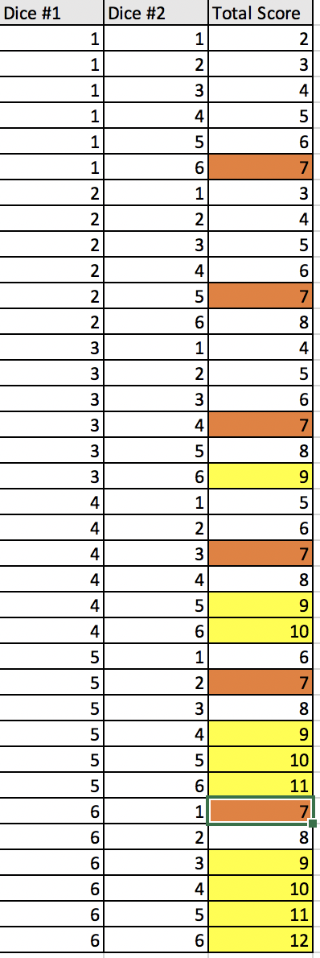
2. A card is drawn at random from a deck. (a) What is the probability that it is an ace or a king? (b) What is the probability that it is either a red card or a black card? ([relevant section](http://onlinestatbook.com/2/probability/basic.html))
   * The probability that the card is an ace or a king is 8/52 or 0.154

$$P\left(ace\right)=\frac{4}{52}$$

$$P\left(king\right)=\frac{4}{52}$$

$$P\left(ace or king\right)=P\left(ace\right)+P\left(king\right) \\ =\frac{4}{52}+\frac{4}{52}$$

$$=\frac{8}{52}$$

= 0.1538

* + The probability that the card is either a red card or a black card is 1.

$$P\left(red\right)=\frac{26}{52}$$

$$P\left(black\right)=\frac{26}{52}$$

$$P\left(red or black\right)=P\left(red\right)+P(black$$

$$=\frac{26}{52}+\frac{26}{52}=1$$

1. A fair coin is flipped 9 times. What is the probability of getting exactly 6 heads? ([relevant section](http://onlinestatbook.com/2/probability/binomial.html))
   * The probability of getting exactly 6 heads is 21/128, or 0.164.
   * 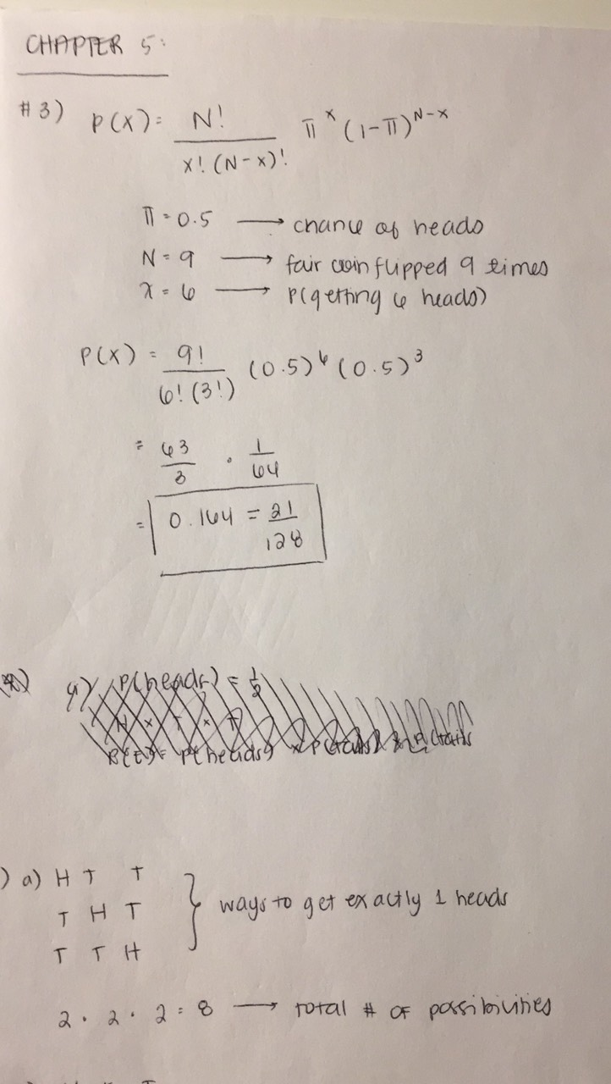
2. You flip a coin three times. (a) What is the probability of getting heads on only one of your flips? (b) What is the probability of getting heads on at least one flip? ([relevant section](http://onlinestatbook.com/2/probability/basic.html) & [relevant section](http://onlinestatbook.com/2/probability/binomial.html))
   * The probability of getting heads on exactly one of the flips is 3/8.
   * The probability of getting heads on at least one flip is 7/8
   * 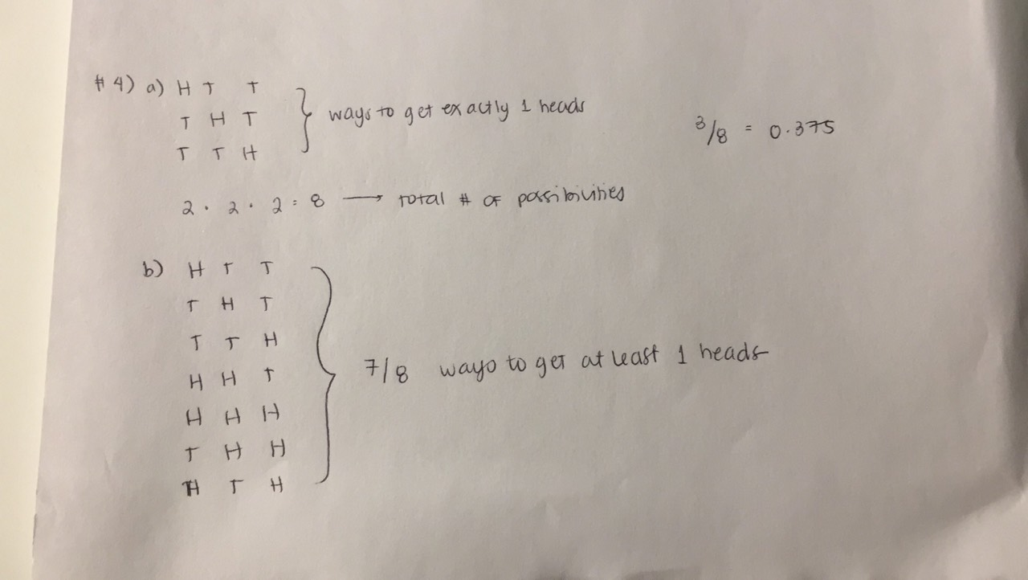
3. A jar contains 10 blue marbles, 5 red marbles, 4 green marbles, and 1 yellow marble. Two marbles are chosen (without replacement). (a) What is the probability that one will be green and the other red? (b) What is the probability that one will be blue and the other yellow? ([relevant section](http://onlinestatbook.com/2/probability/basic.html))
   * Using combination approaches, we know that the probability that one will be green and the other will be red (given no replacement) is 2/19 or 0.105.
   * The probability that one will be blue and the other will be yellow is 1/19 or 0.0526 (given no replacement).
   * 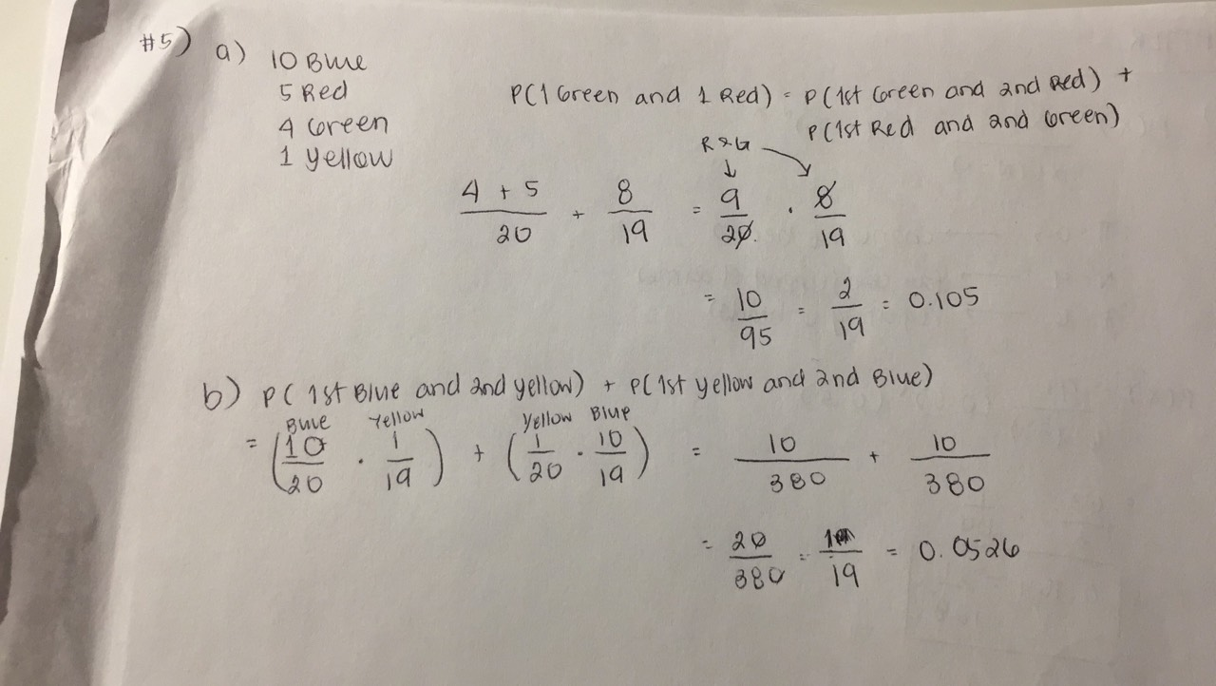

**Chapter 7: Normal Distribution**

1. (a) What are the mean and standard deviation of the standard normal distribution? (b) What would be the mean and standard deviation of a distribution created by multiplying the standard normal distribution by 8 and then adding 75? ([relevant section](http://onlinestatbook.com/2/normal_distribution/standard_normal.html) & [here](http://onlinestatbook.com/2/summarizing_distributions/transformations.html))
   * The mean of a standard normal distribution is 0, and the standard deviation is 1. (the variance is also 1, and it has 0 skewness with a kurtosis = 3).
   * The mean would be 75, since the center of the distribution is currently 0, and then is added to 75. The standard deviation would be multiplied by 8, to get 8.
2. (a) What proportion of a normal distribution is within one standard deviation of the mean? (b) What proportion is more than 2.0 standard deviations from the mean? (c) What proportion is between 1.25 and 2.1 standard deviations above the mean? ([relevant section](http://onlinestatbook.com/2/normal_distribution/standard_normal.html))
   * The proportion of a normal distribution within 1SD (on each side) of the mean is 68.3%. of the data.
   *  image source: <http://my.ilstu.edu/~gjin/hsc204-hed/Module-5-Summary-Measure-2/Module-5-Summary-Measure-28.html>
     1. (If we’re only looking at the proportion of the normal distribution on the left side of 1SD, then we can use the formula to find the cumulative value under the standard normal distribution function. Thus, we know that 81.43% of the values lie on the left side of z = 1.)

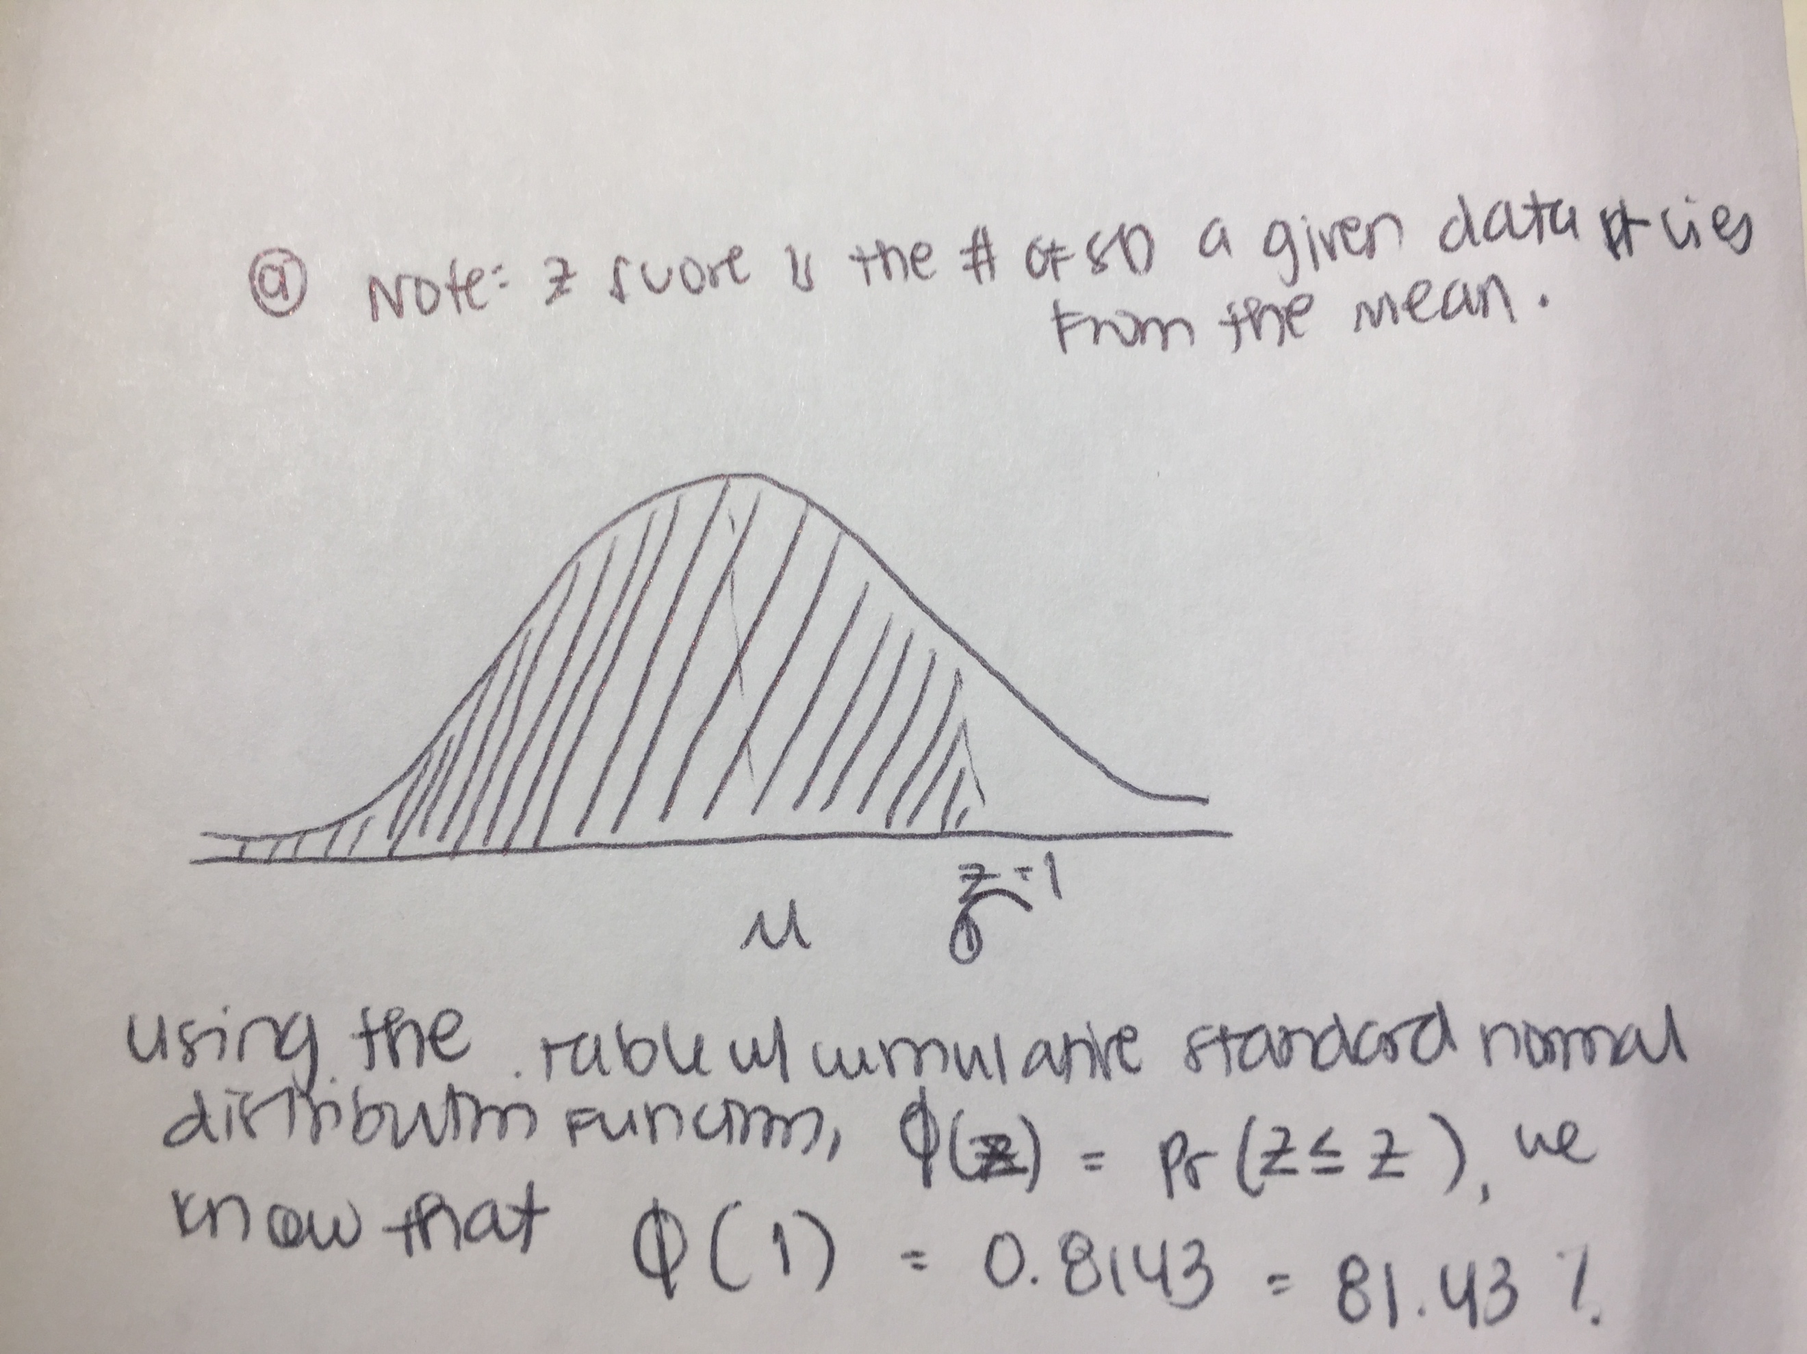

* + The proportion of the normal distribution greater than 2SD of the mean is 100%-95.5% = 4.55% of the data.
    1. (If we are just looking for the percentage of values to the right of 2SD from the mean, then we can compute this using Z scores as well. At a Z score of 2, about 2.28% of the proportion of the normal distribution is more than this.)

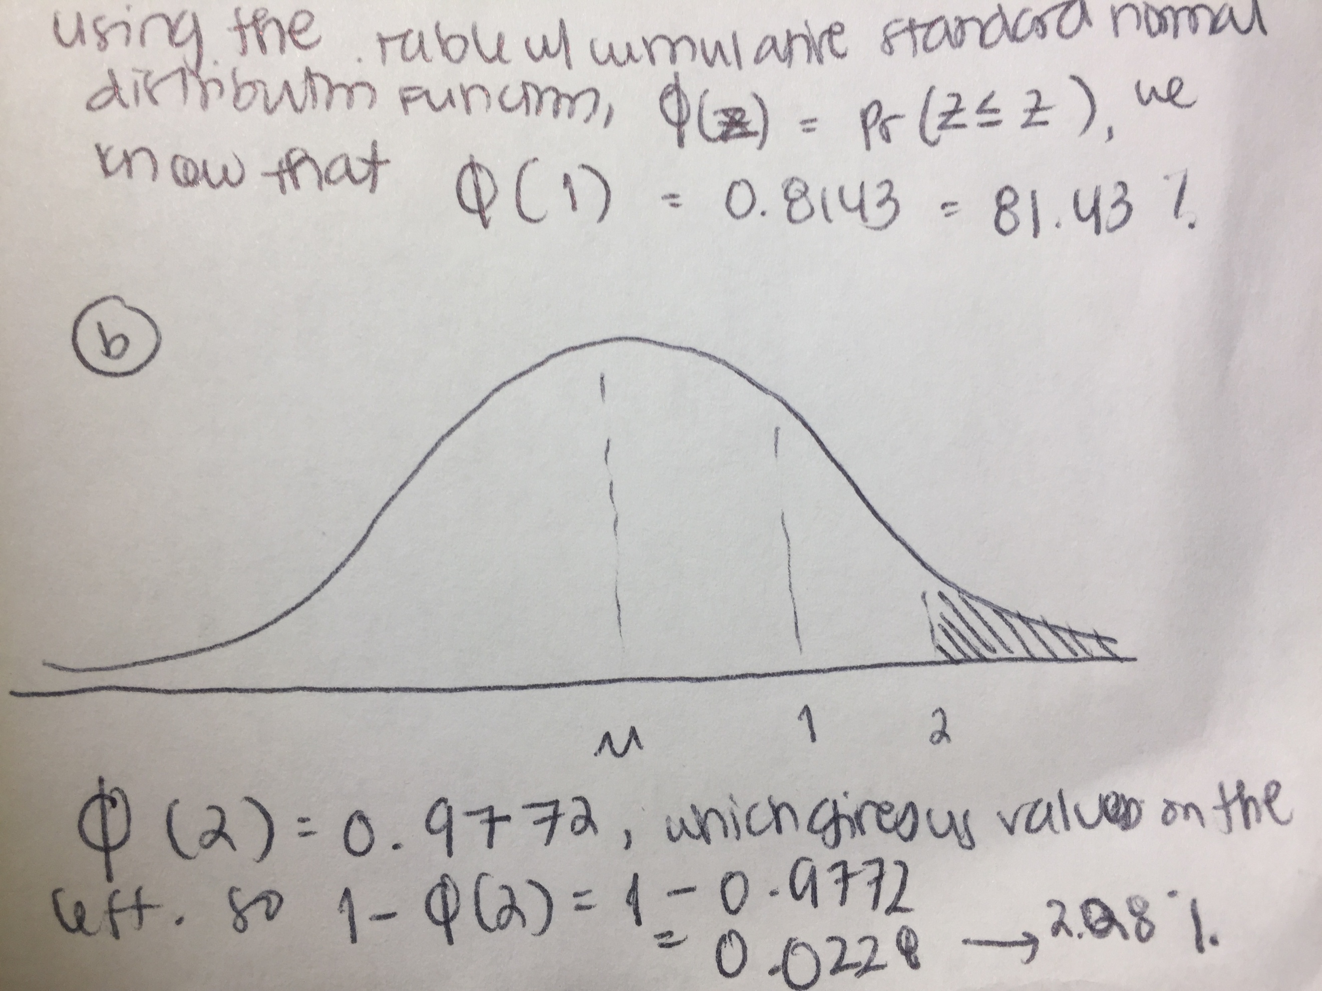

* + About 8.77% of the proportion falls between 1.25 and 2.1 standard deviations above the mean.

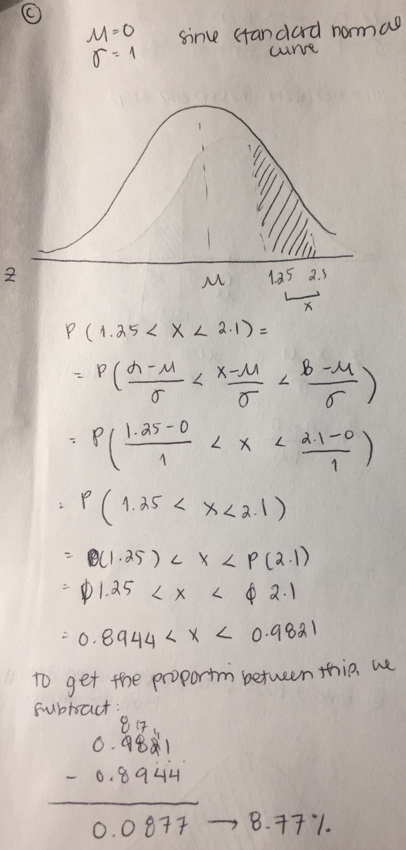

1. Assume a normal distribution with a mean of 70 and a standard deviation of 12. What limits would include the middle 65% of the cases? ([relevant section](http://onlinestatbook.com/2/normal_distribution/areas_normal.html))
   * The limits would be 58.786 and 81.214, based on the standard normal distribution calculator provided by the online textbook.

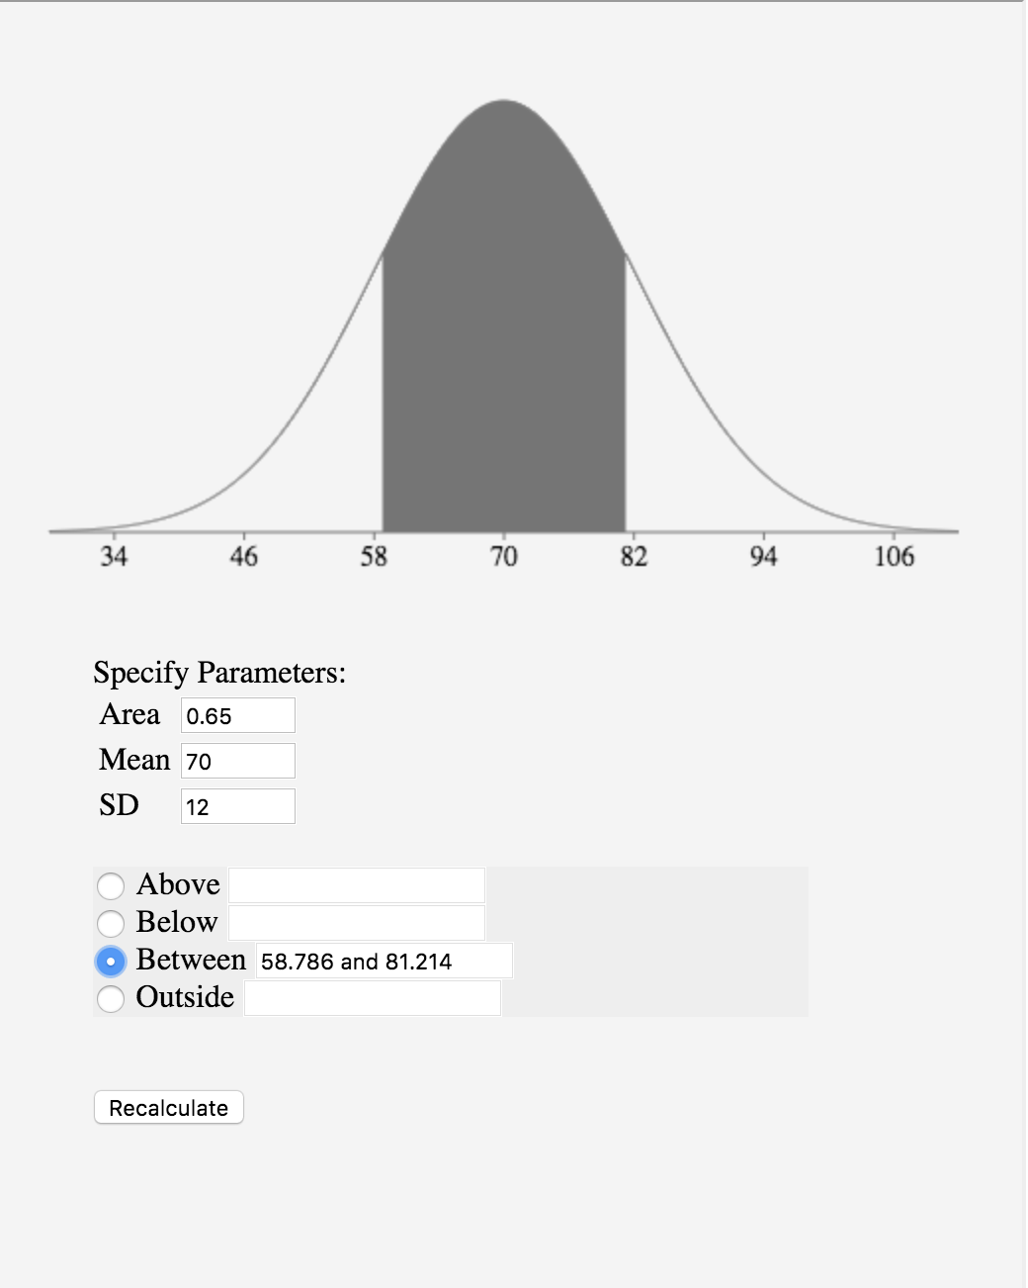

1. Assume the speed of vehicles along a stretch of I-10 has an approximately normal distribution with a mean of 71 mph and a standard deviation of 8 mph.
   * The current speed limit is 65 mph. What is the proportion of vehicles less than or equal to the speed limit?
     1. The proportion of vehicles less than or equal to the current speed limit are 22.66%.
     2. 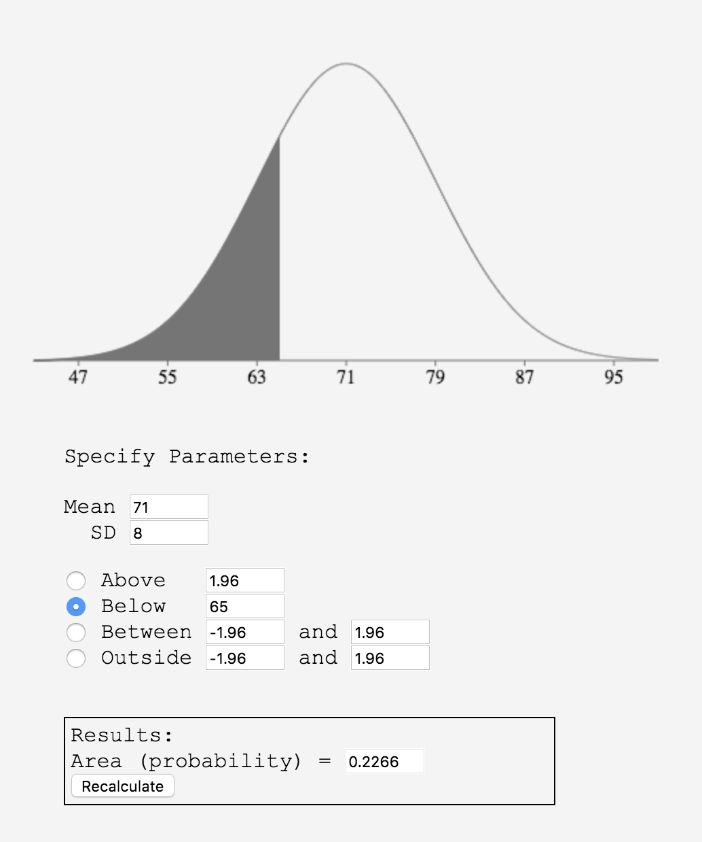
     3. 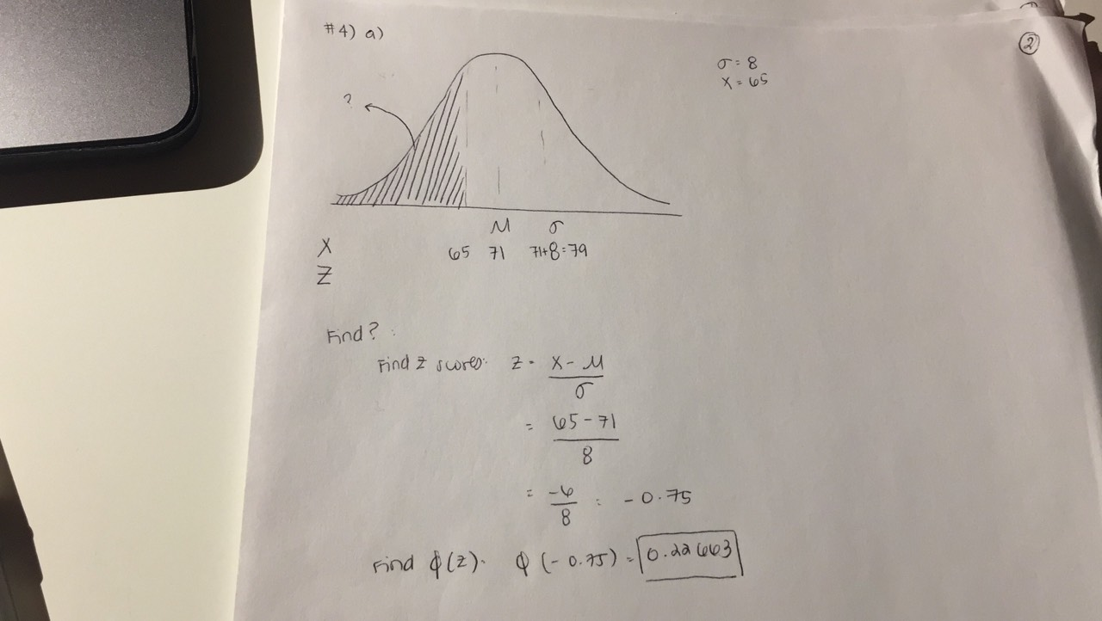
   * What proportion of the vehicles would be going less than 50 mph?
     1. About 0.44% of the vehicles would be going less than 50 mph.
     2. 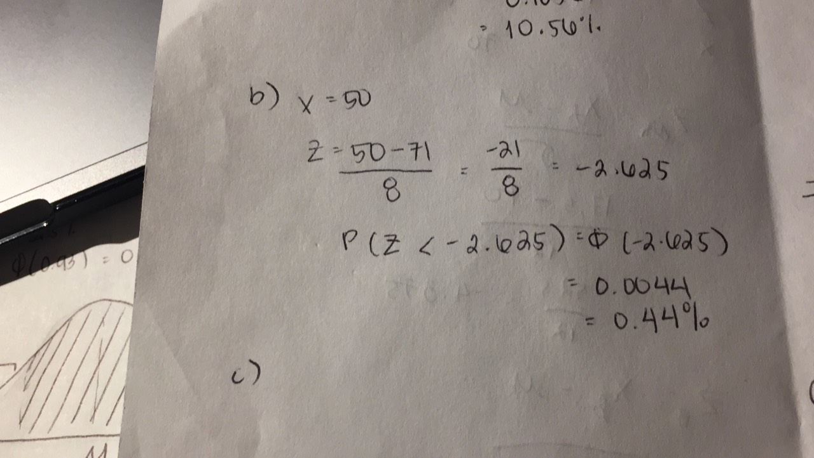
   * A new speed limit will be initiated such that approximately 10% of vehicles will be over the speed limit. What is the new speed limit based on this criterion?
     1. The new speed limit would be 81.32 mph
     2. 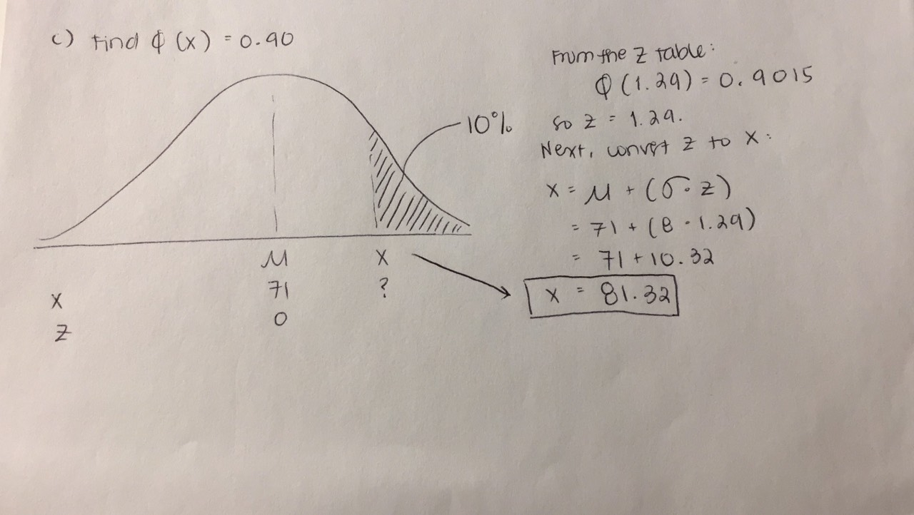
   * In what way do you think the actual distribution of speeds differs from a normal distribution?   
     ([relevant section](http://onlinestatbook.com/2/normal_distribution/areas_normal.html))
     1. The actual distributions of speeds could differ from a normal distribution in terms of how accurately it follows the normal distribution curve. The more speeds we have recorded, the more closely its values will follow a normal distribution shape, and the less skewed it will be, given that it currently has only an “approximately normal distribution” based on the question statement above. This is property is otherwise known as the Central Limit Theorem, which states that the sampling distribution of the mean of any independent, random variable will be normal or nearly normal, if the sample size is large enough.
2. You want to use the normal distribution to approximate the binomial distribution. Explain what you need to do to find the probability of obtaining exactly 7 heads out of 12 flips. ([relevant section](http://onlinestatbook.com/2/normal_distribution/normal_approx.html))
   * The probability of obtaining 6.5 to 7.5 heads is 19.48%. Outlined below is my solution. It’s important to note that the binomial distribution is discrete and the normal distribution is continuous, which is why getting ranges like the below solution is useful.
   * 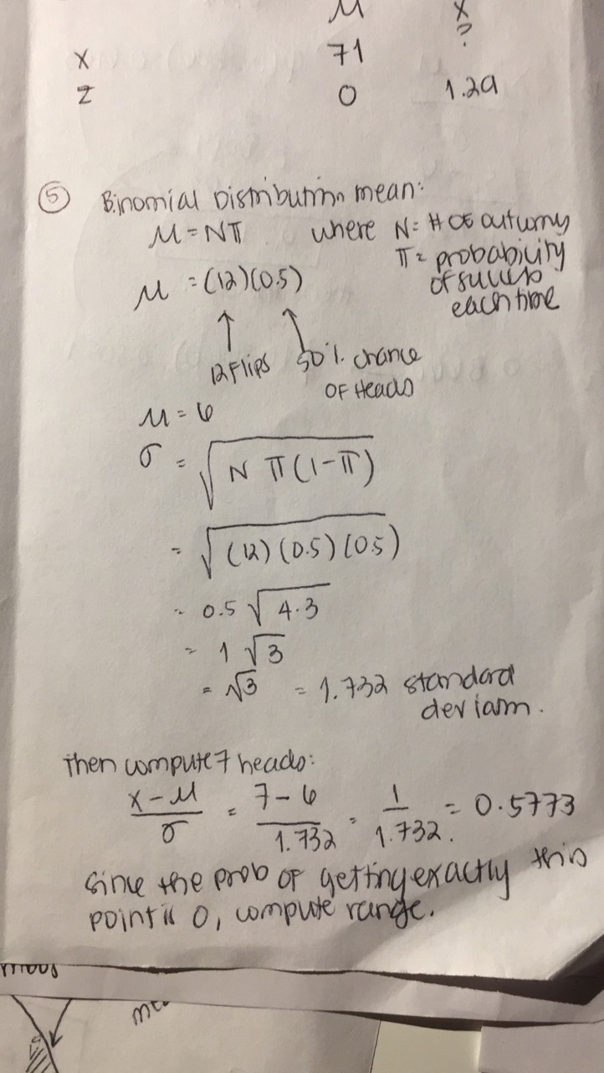 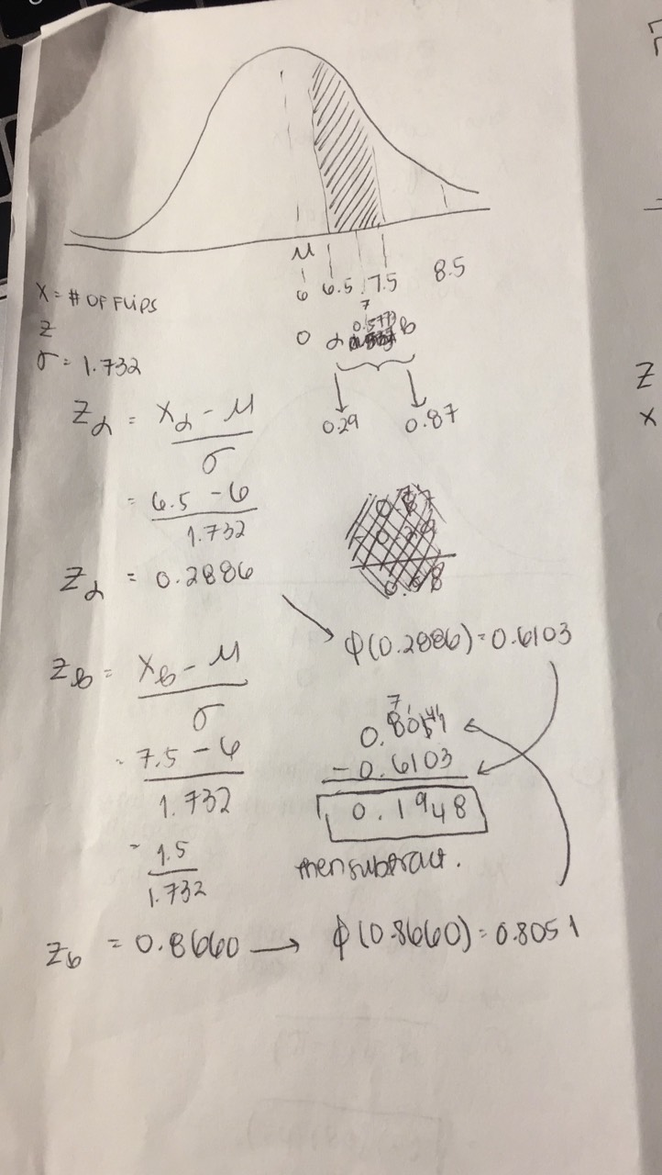

**Chapter 9: Sampling Distributions**

1. A population has a mean of 50 and a standard deviation of 6.
   * (a) What are the mean and standard deviation of the sampling distribution of the mean for N = 16?
     1. The mean of the sampling distribution of the mean if N=16 is 50
     2. The standard deviation is 1.5
   * (b) What are the mean and standard deviation of the sampling distribution of the mean for N = 20? ([relevant section](http://onlinestatbook.com/2/sampling_distributions/samp_dist_mean.html))
     1. Mean = 50
     2. Standard deviation = 1.341
2. What term refers to the standard deviation of the sampling distribution? ([relevant section](http://onlinestatbook.com/2/sampling_distributions/intro_samp_dist.html))
   * The standard error (of the mean) is the standard deviation of the sampling distribution from the sample mean.
3. A questionnaire is developed to assess women's and men's attitudes toward using animals in research. One question asks whether animal research is wrong and is answered on a 7-point scale. Assume that in the population, the mean for women is 5, the mean for men is 4, and the standard deviation for both groups is 1.5. Assume the scores are normally distributed. If 12 women and 12 men are selected randomly, what is the probability that the mean of the women will be more than 1.5 points higher than the mean of the men? ([relevant section](http://onlinestatbook.com/2/sampling_distributions/samplingdist_diff_means.html))
   * The probability is 20.9%
   * 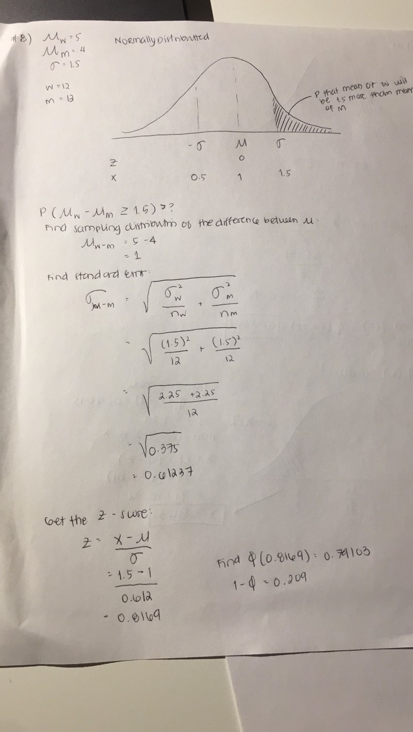
   * 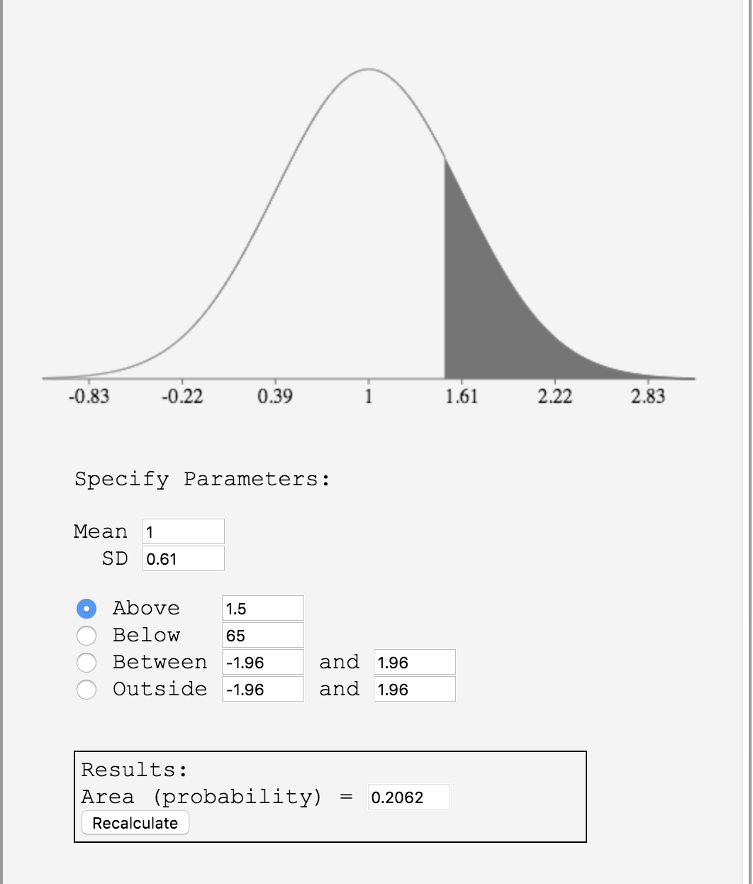
4. If numerous samples of N = 15 are taken from a uniform distribution and a relative frequency distribution of the means is drawn, what would be the shape of the frequency distribution? ([relevant section](http://onlinestatbook.com/2/sampling_distributions/samp_dist_mean.html) & [relevant section](http://onlinestatbook.com/2/sampling_distributions/clt_demo.html))
   * The higher the number of samples of N=15 that are taken from a uniform distribution, the closer the relative frequency distribution will be to the shape of a normal distribution. This property is known as the Central Limit Theorem, which states that the sampling distribution of the mean of any independent random variable will be normal or near normal if the sample size is large enough. Moreover, the more closely the original population resembles a normal distribution, the fewer sample points will be required for the new distribution to resemble a normal distribution.
5. What is the shape of the sampling distribution of r? In what way does the shape depend on the size of the population correlation? ([relevant section](http://onlinestatbook.com/2/sampling_distributions/samp_dist_r.html))
   * The shape of the sampling distribution of r is usually (negatively) skewed, unless r is 0. The reason for this is that r cannot take on values greater than 1.0 or less than -1.0, so its distribution cannot extend as far in one direction as it can in the other direction. The greater the value of p, the more pronounced the skew of r’s distribution. To convert Pearson’s r to a value that’s normally distributed, we can use a transformation called Fisher’s z transformation.
6. A variable is normally distributed with a mean of 120 and a standard deviation of 5. Four scores are randomly sampled. What is the probability that the mean of the four scores is above 127? ([relevant section](http://onlinestatbook.com/2/sampling_distributions/samp_dist_mean.html))
   * The probability of getting a value above 127 is 0.26%.
   * The mean of the sampling distribution is the mean of the population from which the scores were sampled, thus if the mean of the population is 120, then the mean of the sample will also be 120. To get the SD we need to divide 5 by the square root of 4, which is n—we are comparing the sample, and not the population. To get the probability of a value being above 127, we can use the normal distribution calculator provided on the website.
   * 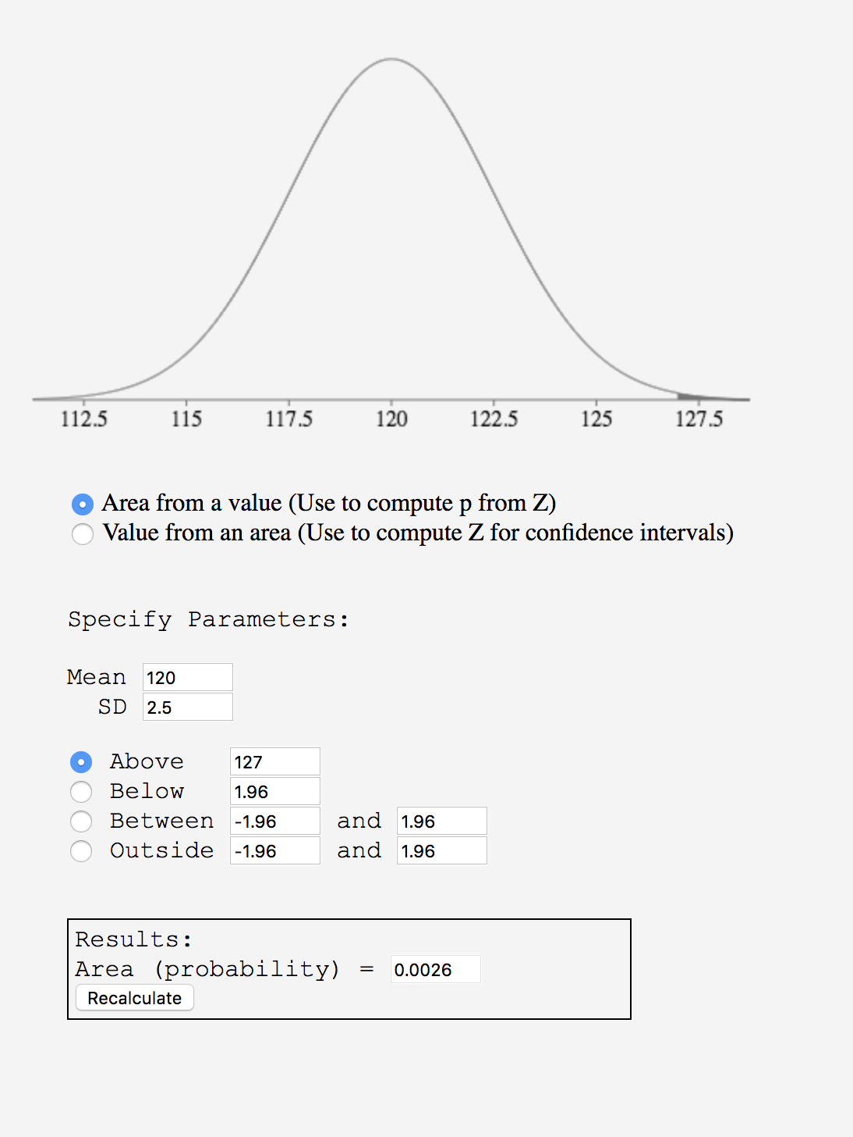
7. The mean GPA for students in School A is 3.0; the mean GPA for students in School B is 2.8. The standard deviation in both schools is 0.25. The GPAs of both schools are normally distributed. If 9 students are randomly sampled from each school, what is the probability that:
   * (a) the sample mean for School A will exceed that of School B by 0.5 or more? ([relevant section](http://onlinestatbook.com/2/sampling_distributions/samplingdist_diff_means.html))
     1. The probability that the sample mean for School A will exceed School B by 0.5 or more is 0.5%
     2. 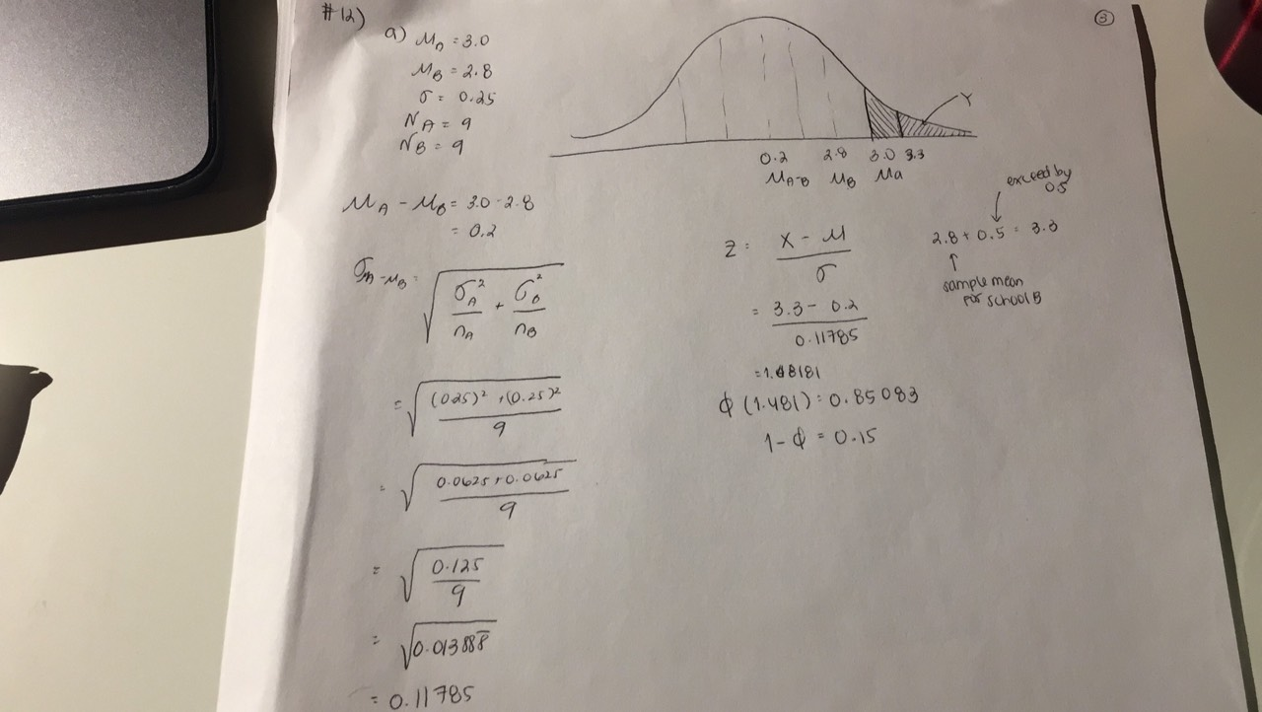 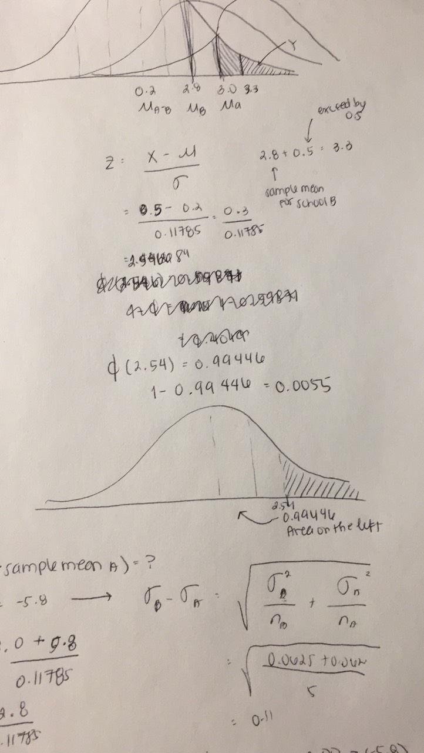
     3. 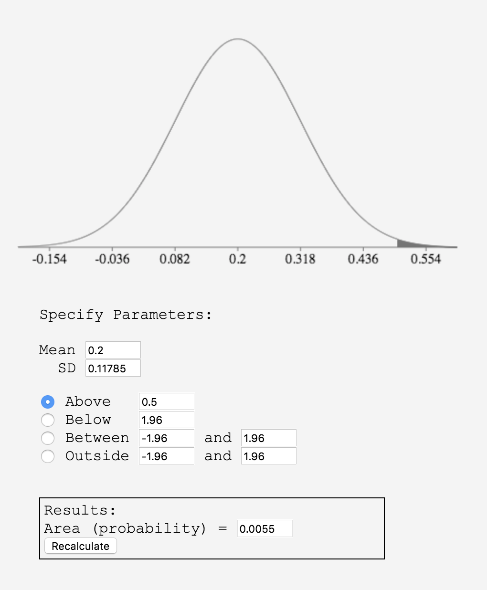
   * (b) the sample mean for School B will be greater than the Sample Mean for School A? ([relevant section](http://onlinestatbook.com/2/sampling_distributions/samplingdist_diff_means.html))
     1. The probability that the sample mean for School B will exceed School A is 4.46%
     2. 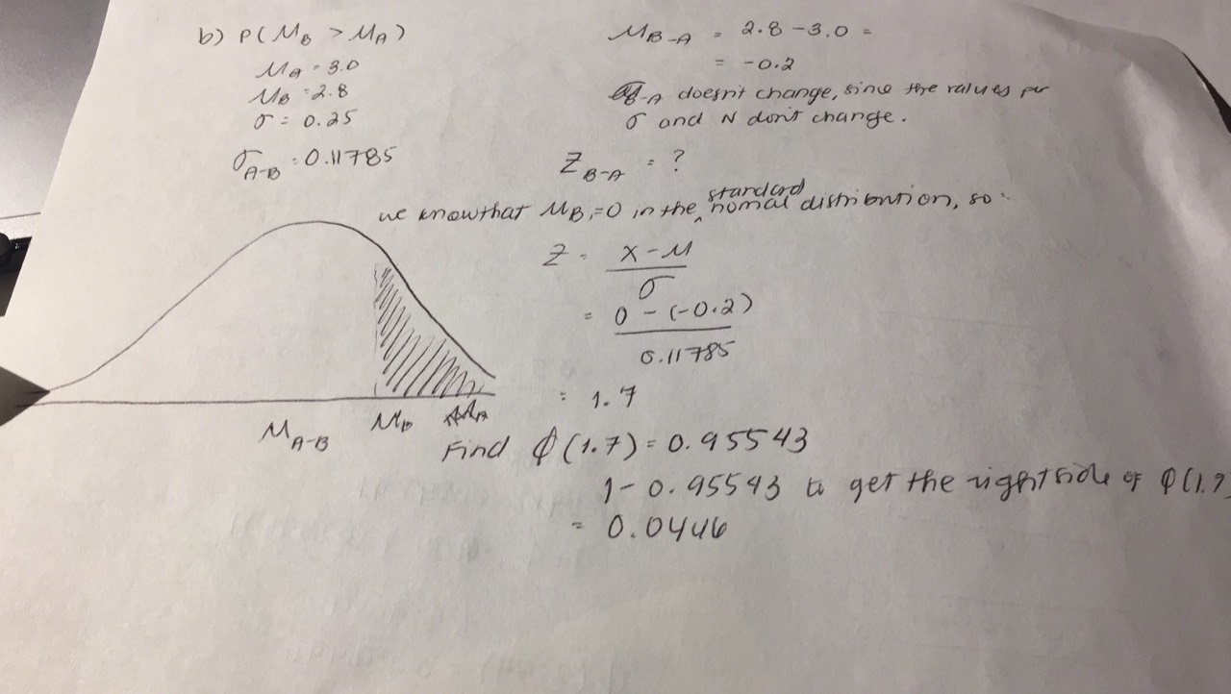
8. When solving problems where you need the sampling distribution of r, what is the reason for converting from r to z'? ([relevant section](http://onlinestatbook.com/2/sampling_distributions/samp_dist_r.html))
   * The reason we convert r to z’ is to transform the variables into ones that have a normal distribution. Without a normal distribution, it would be very difficult to compute probabilities and the standard errors of the sampling distribution of r. Thus, by using the Fisher method, we can transform r into a variable that is normally distributed and that has a known standard error of  and is thus much easier to work with.
9. True/false: The standard error of the mean is smaller when N = 20 than when N = 10. ([relevant section](http://onlinestatbook.com/2/sampling_distributions/samp_dist_mean.html))
   * True, the standard error of the mean is smaller when N is larger. This is true since we know that the larger the sample size, the smaller the variance of the sampling distribution of the mean. We can derive this from the variance sum law. Since the variance of N numbers the sampling distribution is Nσ2 , and we know that the mean is 1/N times the sum, we can then determine that the variance of the sampling distribution of the mean would be 1/N2 times the variance of the sum, which gives us σ2/N.
10. True/false: You choose 20 students from the population and calculate the mean of their test scores. You repeat this process 100 times and plot the distribution of the means. In this case, the sample size is 100. ([relevant section](http://onlinestatbook.com/2/sampling_distributions/samp_dist_mean.html) & [relevant section](http://onlinestatbook.com/2/sampling_distributions/SampDist_v1.html))
    * False, the sample size is 20 students out of the population. We are only using these same 20 students from the population, even though we are repeating the process 100 times.
11. True/false: The median has a sampling distribution. ([relevant section](http://onlinestatbook.com/2/sampling_distributions/intro_samp_dist.html))
    * True, all statistics have sampling distributions. In particular, the standard error of the median for large samples and normal distributions is the following:
    * 
    * Attached here is also a very useful website for exploring the sampling distribution of the median for non-normal distributions: <http://onlinestatbook.com/stat_sim/sampling_dist/index.html>